
PERTH COLLEGE

Trial Western Australian Certificate of Education

Examination, 2010

Question/Answer Booklet

MATHEMATICS
If required by your examination administrator, please place your student identification label in this box

3C/3D

Section Two:

Calculator-assumed

Student Number: In figures

In words

Time allowed for this section
Reading time before commencing work: ten minutes
Working time for this section: one hundred minutes

Material required/recommended for this section

To be provided by the supervisor
This Question/Answer booklet
Formula sheet (retained from Section One)

To be provided by the candidate
Standard items: pens, pencils, pencil sharpener, eraser, correction fluid/tape, ruler, highlighters

Special items: drawing instruments, templates, notes on two unfolded sheets of A4 paper,
and up to three calculators satisfying the conditions set by the Curriculum
Council for this examination.

Important note to candidates

No other items may be taken into the examination room. It is your responsibility to ensure that you do not have any unauthorised notes or other items of a non-personal nature in the examination room. If you have any unauthorised material with you, hand it to the supervisor before reading any further.

Structure of this paper

Section | Number of questions available | Number of questions to be answered | Working time (minutes) | Marks available
Section One:  Calculator-free | 9 | 9 | 50 | 40
Section Two:  Calculator-assumed | 12 | 12 | 100 | 80
 |  |  |  | 120

Instructions to candidates

- The rules for the conduct of Western Australian external examinations are detailed in the Year 12 Information Handbook 2010. Sitting this examination implies that you agree to abide by these rules.

- Write your answers in the spaces provided in this Question/Answer Booklet. Spare pages are included at the end of this booklet. They can be used for planning your responses and/or as additional space if required to continue an answer.
- Planning: If you use the spare pages for planning, indicate this clearly at the top of the page.
- Continuing an answer: If you need to use the space to continue an answer, indicate in the original answer space where the answer is continued, i.e. give the page number. Fill in the number of the question(s) that you are continuing to answer at the top of the page.

- Show all your working clearly. Your working should be in sufficient detail to allow your answers to be checked readily and for marks to be awarded for reasoning. Incorrect answers given without supporting reasoning cannot be allocated any marks. For any question or part question worth more than two marks, valid working or justification is required to receive full marks. If you repeat an answer to any question, ensure that you cancel the answer you do not wish to have marked.

- It is recommended that you do not use pencil except in diagrams.

Section Two: Calculator-assumed (80 Marks)

This section has twelve (12) questions. Answer all questions. Write your answers in the space provided.

Suggested working time for this section is 100 minutes.

Question 10 (4 marks)

A spherical balloon is being blown up. When its radius is increasing at a rate of 1.5 cm per second, its volume is 905 cm. What is the rate at which the volume is increasing at this instant?
Question 11 (7 marks)

When an unfair coin is tossed, it has an 80% chance of landing heads up. Assign the value 1 to X if it lands heads up and 0 to X if it lands tails up.

(a) Use this information to complete the table below which shows all possible sample outcomes for experiments of tossing the coin 4 times. Calculate their corresponding probabilities, assign values and calculate the mean  each time. (3 marks)

Outcome | Probability | 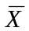
HHHH
HHHT
HHTH | 0.1024
HTHH
THHH
HHTT
HTHT
HTTH
THTH
THHT
TTHH
HTTT
THTT
TTHT
TTTH
TTTT

(b) Use your data from part (a) to create a sampling distribution in the table below. Let be the possible values of the means obtained in table (a). (1 mark)

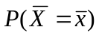

(c) What type of statistical distribution does that in part (b) resemble? (1 mark)

(d) If the sample size (number of times the coin is tossed) were to be increased from 4, describe how the type of distribution you have could change. Name any rules or theorems that may apply. (2 marks)

Question 12 (3 marks)

A new drug can kill off a live mould in a petri dish according to the rule 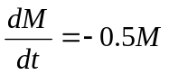, where M is the amount of live mould in the petri dish when the drug was added to it and t is the time in hours since it was added.

How long will it take for the size of the mound to reduce to 20% of the original amount? Give your answer correct to 2 significant figures.
Question 13 (11 marks)

Every weekday the chef at a restaurant sends out an apprentice to the local market to spend as little as possible and at the same time come back with at least 16kg of onions, at least 17kg of carrots and at least 21kg of potatoes.

One stall at the market sells 'Best Buy' packs consisting of 2kg of onions, 1kg of carrots and 1kg of potatoes for $3.50 each. Another stall sells 'Chefs Choice' packs consisting of 1kg of onions, 2kg of carrots and 3kg of potatoes for $6.50 each.

The apprentice buys 'Best Buy' packs and 'Chefs Choice packs.

(a) Write down three inequalities to represent the above constraints, apart from 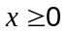 and 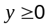. (2 marks)

(b) Complete the constraints on the graph below and indicate the feasible region. (3 marks)
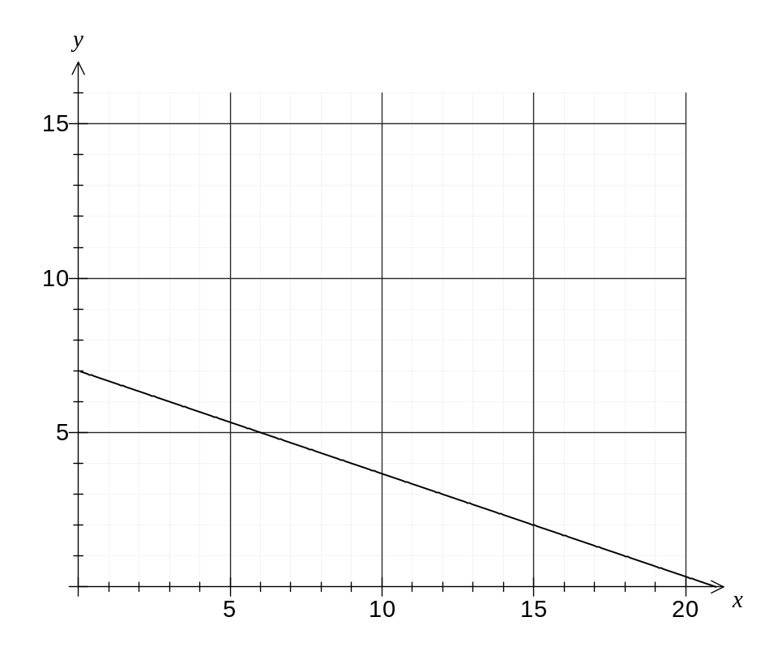
(c) How many of each pack should the apprentice buy to minimise the purchase cost and
what is the minimum cost? (3 marks)

(d) By how much can the price of a 'Best Buy' pack rise without changing the optimum number of packs found in your answer to (c)? (3 marks)

Question 14 (7 marks)

Two spheres fit inside an inverted cone as shown in the diagram below. Circle centre O has radius 4 cm and circle centre R has radius 2 cm.

(a) Prove that Δ PRS is congruent to Δ ROM. Hint: draw a perpendicular from R to OT.
(4 marks)

(b) Hence, or otherwise, calculate the height that the centre of the larger sphere is above the vertex of the cone, citing any theorems or axioms or previously deduced facts used in the logical steps needed to get the answer. (3 marks)

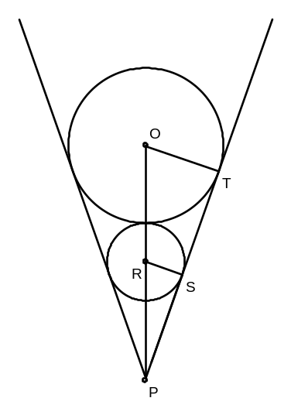

Question 15 (7 marks)
The graph below, not to scale, shows the functions 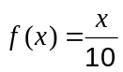, 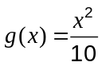 and the line 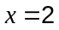.
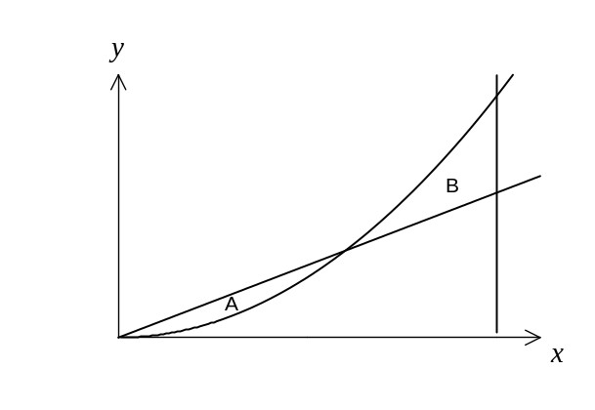
Region A is the area trapped by 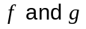.
Region B is the area trapped by 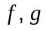 and the line .

(a) Find the areas of regions A and B. (3 marks)

(b)  is modified to become the line 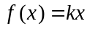, so that the area of region A is exactly the same as the area of region B. Determine the value of . (4 marks)

Question 16 (6 marks)

When new lathes were bought for the fabrication section of a large manufacturer of steel products, 60% of the employees attended a special training course on how to use them. Of these 85% passed the competency test for working on them.

(a) If 10% of the employees didn’t go on the course because they already had the competency qualifications to use them, what percentage of employees is now qualified to use the new lathes? (4 marks)

(b) What is the probability that a randomly chosen employee attended the training course, given that they are found not to be qualified to use the new lathes? (2 marks)

Question 17 (7 marks)

(a) Show that the surface area and volume of any cube are related to each other by deriving the formula 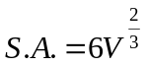 where S.A. is surface area and V is volume. (2 marks)

(b) Use calculus to find the approximate percentage change in surface area if the volume increases by 12%. (5 marks)

Question 18 (7 marks)

In a quiet country town, the waiting time to get onto a roundabout through a particular entry point during the afternoon peak hour can be represented by a random variable in a normal distribution. The mean waiting time is 75 seconds, with a standard deviation of 25 seconds. Give answers to 4 decimal places.

(a) What is the probability that a motorist has a wait of less than 5 seconds? (1 mark)

(b) Evaluate the probability that a motorist has to wait more than a minute and a half.
(1 mark)

(c) What is the probability that the wait is between 1 and 2 minutes? (1 mark)

(d) Given that a motorist has already been waiting behind one other car for 30 seconds, what is the probability that once he gets onto the roundabout he will have waited at most a total of 125 seconds before being able to enter it? (2 marks)

(e) A resident of the town passes through this intersection during the afternoon peak hour every day from Monday to Friday in a particular week. What is the probability that this motorist has to wait between 1 and 2 minutes on at least 3 of these days? (2 marks)
Question 19 (7 marks)

The mass of tahini in a particular type of jar is a normally distributed random variable, whose standard deviation is 2.75 g and whose mean g is unknown.

In studying a random sample of n such jars, the average mass of tahini per jar for the sample is g.

(a) What should the least sample size n be, if we want to be 99% confident that differs from  by less than 1.5 g? (3 marks)

The average mass of tahini in one random sample of 25 such jars is 250.2 g.

(b) Calculate a 95% confidence interval for. (2 marks)

(c) For customer satisfaction, the desired amount of tahini in a jar is to be the amount stated on the label (which is 250g) or perhaps a little over rather than under that amount. Explain what the tahini producers can infer from the confidence interval obtained in your answer to part (b) and what choices they might then decide to make.
(2 marks)

Question 20 (8 marks)

A particle is moving under rectilinear motion with velocity v(t) =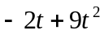 m/s. Answer the following questions for the movement of the particle over the time interval 0 ≤ t ≤ 6.

(a) If the particle was initially 2 m to the right of the origin, what is the displacement from the origin after 2 seconds? (2 marks)

(b) How far did the particle travel in the first 2 seconds? (2 marks)

(c) When was the particle moving fastest? Show all reasoning. (2 mark)

(d) For what subset(s) of the given time interval is the acceleration negative? (2 marks)

Question 21 (6 marks)

The internal contours of a barrel are defined by the rotation about the x axis of the curve
y = 0.1(x + 3)(7 – x) between x =  and x = 5
Each unit on both the x and y axes represents 15 cm.

(a) Sketch and label this situation on the axes below. (1 mark)

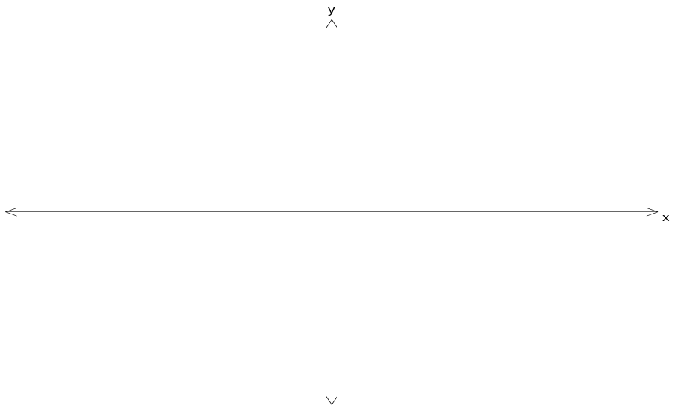

(b) When the barrel is filled to its brim, how many litres can it hold? Give your answer correct to one decimal place. (5 marks)

Additional working space
Question number(s):
Additional working space
Question number(s):

Additional working space
Question number(s):

Section One

 |  | Your Mark
Total | 40

Section Two

Question Number | Available Marks | Your Mark
10 | 4
11 | 7
12 | 3
13 | 11
14 | 7
15 | 7
16 | 6
17 | 7
18 | 7
19 | 7
20 | 8
21 | 6
Total | 80

 |  | Your Mark
Total | 120
 |  | %

